**NAME: SHIVAM TIWARI**

**ROLL NO: 5117060**

**EXPERIMENT 06**

**Aim:** Implementation of Image negative, Gray level Slicing and Thresholding.

**Theory:**

**Image Negatives**

Image negatives, most of you might have heard this term, in good old days were used to produce images. Film Photography has not yet become obsolete as some wedding photographers are still shooting film. Because one has to pay for the film rolls and processing fees, most people have now switched to digital.

I recently heard of Foveon X3 direct image sensor which claims to combine the power of digital sensor with the essence of the film. (Check [here](http://www.foveon.com/article.php?a=67))

Image negative is produced by subtracting each pixel from the maximum intensity value. e.g. for an 8-bit image, the max intensity value is 28– 1 = 255, thus each pixel is subtracted from 255 to produce the output image.

Thus, the transformation function used in image negative is

**s = T(r) = L – 1 – r**

Where L-1 is the max intensity value and s, and r are the output and input pixel values respectively.

For gray scale image, light areas appear dark and vice versa. For color image, colors are replaced by their complementary colors. Thus, red areas appear cyan, greens appears magenta, and blues appears yellow, and vice versa.

**Grayscale**

Grayscale is a range of [monochromatic](https://techterms.com/definition/monochrome) shades from black to white. Therefore, a grayscale image contains only shades of gray and no color.

While [digital](https://techterms.com/definition/digital) images can be saved as grayscale (or black and white) images, even color images contain grayscale information. This is because each [pixel](https://techterms.com/definition/pixel) has a luminance value, regardless of its color. Luminance can also be described as brightness or intensity, which can be measured on a scale from black (zero intensity) to white (full intensity). Most image [file formats](https://techterms.com/definition/file_format) support a minimum of 8-bit grayscale, which provides 2^8 or 256 levels of luminance per pixel. Some formats support 16-bit grayscale, which provides 2^16 or 65,536 levels of luminance.

**Thresholding**

In [digital image processing](https://en.wikipedia.org/wiki/Digital_image_processing), **thresholding** is the simplest method of [segmenting images](https://en.wikipedia.org/wiki/Image_segmentation). From a [grayscale](https://en.wikipedia.org/wiki/Grayscale) image, thresholding can be used to create [binary images](https://en.wikipedia.org/wiki/Binary_image).

The simplest thresholding methods replace each pixel in an image with a black pixel if the image intensity  is less than some fixed constant T (that is, ), or a white pixel if the image intensity is greater than that constant. In the example image on the right, this results in the dark tree becoming completely black, and the white snow becoming completely white.

Conclusion: Thus, we have successfully implementedImage negative, Gray level Slicing and Thresholding.

**Code:**

import cv2

img = cv2.imread("C:\\Users\\asus\\Desktop\\car.png")

cv2.imshow("Pic",img)

img_not = cv2.bitwise_not(img)

cv2.imshow("Invert1",img_not)

cv2.waitKey(0)

cv2.destroyAllWindows()

**Output:**



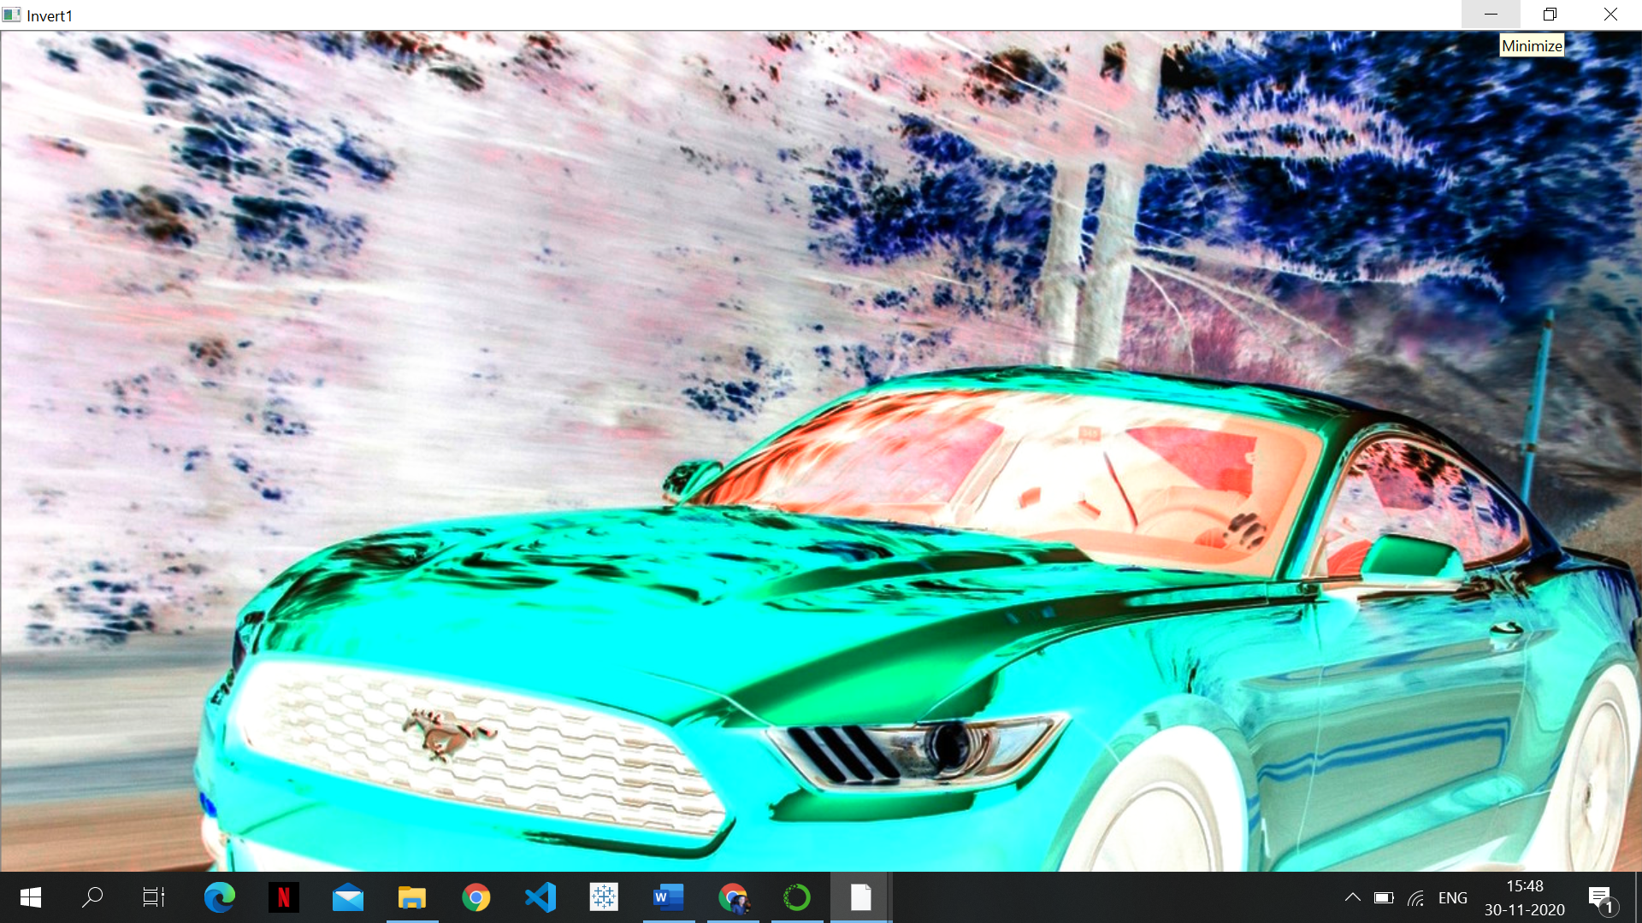

**Gray Scaling**

import cv2

# Load our input image

image = cv2.imread('C:\\Users\\asus\\Desktop\\car.png')

cv2.imshow('Original', image)

cv2.waitKey()

# We use cvtColor, to convert to grayscale

gray_image = cv2.cvtColor(image, cv2.COLOR_BGR2GRAY)

cv2.imshow('Grayscale', gray_image)

cv2.waitKey(0)

# window shown waits for any key pressing event

cv2.destroyAllWindows()

**Output:**

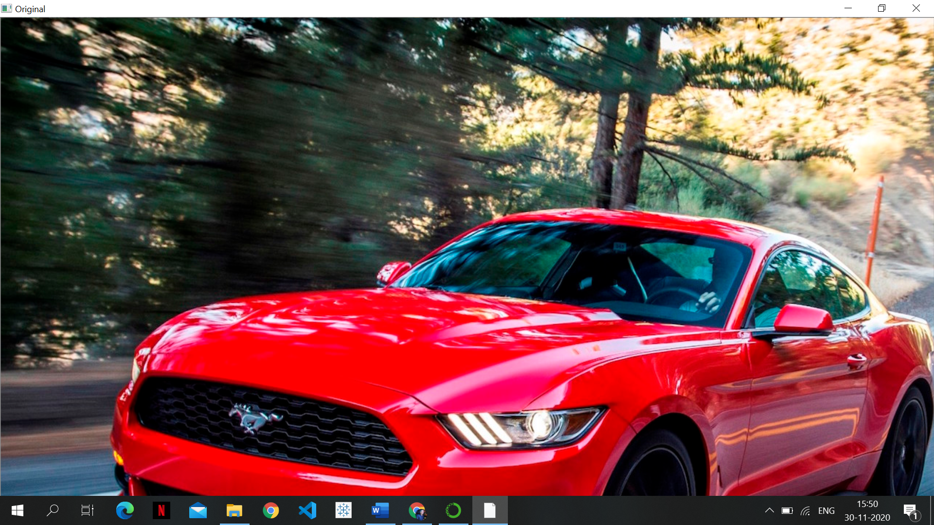

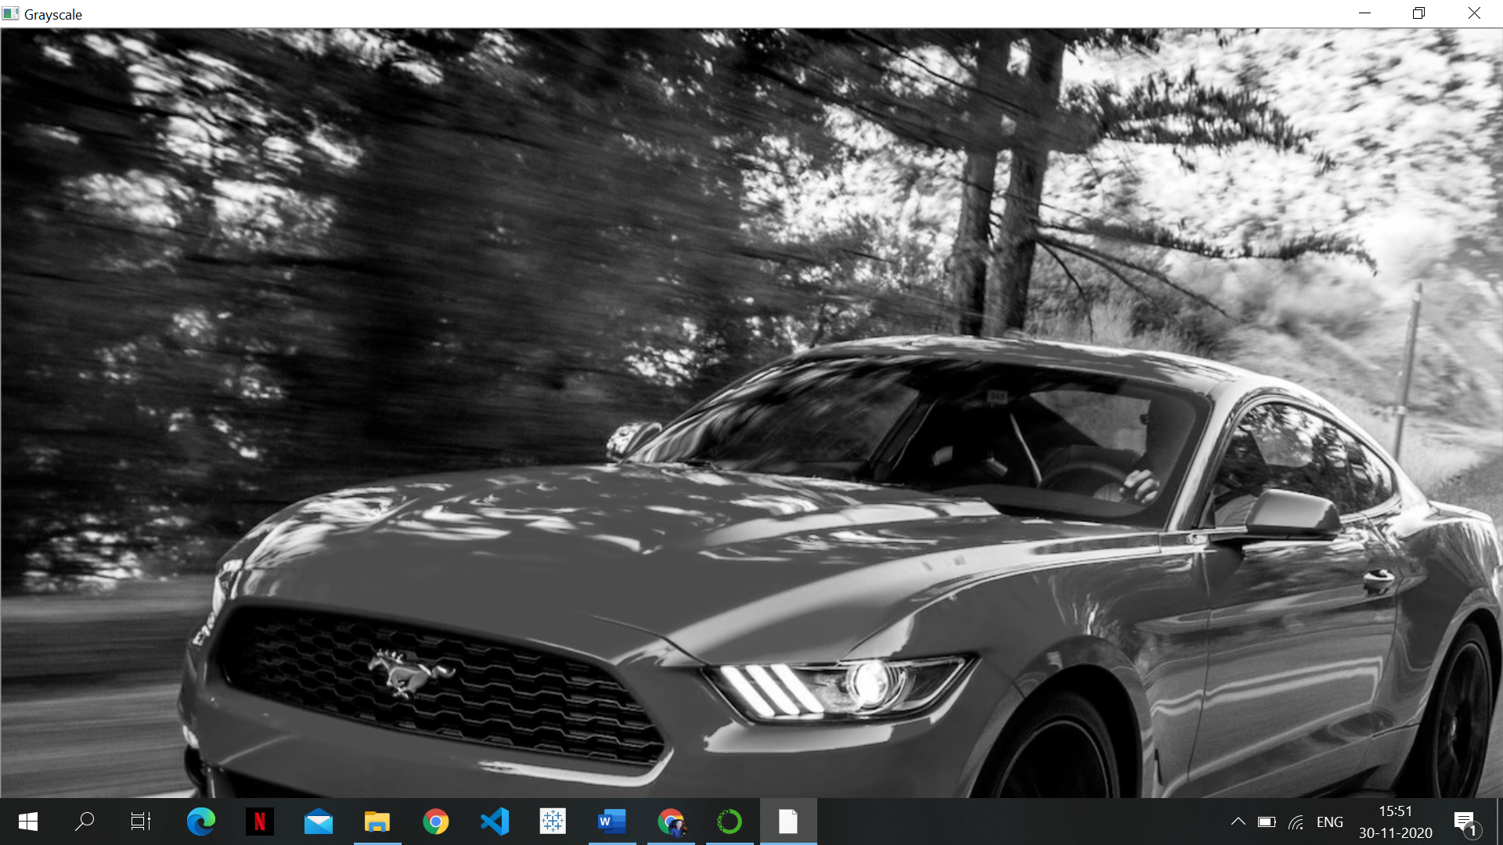

**Thresholding**

import cv2

import numpy as np

from matplotlib import pyplot as plt

img = cv2.imread('C:\\Users\\asus\\Desktop\\car.png',0)

img = cv2.medianBlur(img,5)

ret,th1 = cv2.threshold(img,127,255,cv2.THRESH_BINARY)

th2 = cv2.adaptiveThreshold(img,255,cv2.ADAPTIVE_THRESH_MEAN_C,\

cv2.THRESH_BINARY,11,2)

th3 = cv2.adaptiveThreshold(img,255,cv2.ADAPTIVE_THRESH_GAUSSIAN_C,\

cv2.THRESH_BINARY,11,2)

titles = ['Original Image', 'Global Thresholding (v = 127)',

'Adaptive Mean Thresholding', 'Adaptive Gaussian Thresholding']

images = [img, th1, th2, th3]

for i in range(4):

plt.subplot(2,2,i+1),plt.imshow(images[i],'gray')

plt.title(titles[i])

plt.xticks([]),plt.yticks([])

plt.show()

**Output:**

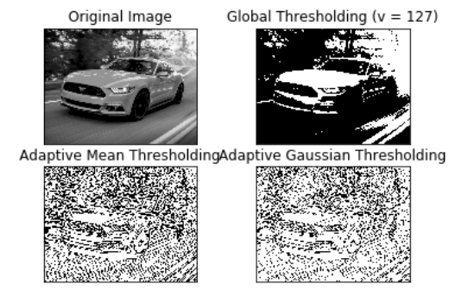

**Experiment 7**

# Aim: Implementation of Contrast Stretching, Dynamic range compression & Bit plane Slicing.

**Theory:**

**Contrast Stretching:**

The enhancement techniques are employed in order to increase the contrast of an image. Generally, an image can be enhanced by spreading out the range of scene illumination. This procedure is called contrast stretching. Contrast stretching (often called normalization) is a simple image enhancement technique that attempts to improve the contrast in an image by ‘stretching’ the range of intensity values it contains to span a desired range of values, the full range of pixel values that the image type concerned allows. Contrast stretching changes the distribution and range of the digital numbers assigned to each pixel in an image. This is normally done to accent image details that may be difficult for the human viewer to observe. Our main goal in this paper is to apply a contrast enhancement technique to recover an image from blurred images, also improve image quality of it. Our technique consists of two steps, locally contrast stretching step and globally contrast stretching step to enhance Ziehl-Neelsen tissue section slide images.

**Dynamic Range Compression**

**Dynamic range compression** (**DRC**) or simply **compression** is an [audio signal processing](https://en.wikipedia.org/wiki/Audio_signal_processing) operation that reduces the volume of loud [sounds](https://en.wikipedia.org/wiki/Sound) or amplifies quiet sounds, thus reducing or *compressing* an [audio signal](https://en.wikipedia.org/wiki/Audio_signal)'s [dynamic range](https://en.wikipedia.org/wiki/Dynamic_range). Compression is commonly used in [sound recording and reproduction](https://en.wikipedia.org/wiki/Sound_recording_and_reproduction), [broadcasting](https://en.wikipedia.org/wiki/Broadcasting),[[1]](https://en.wikipedia.org/wiki/Dynamic_range_compression#cite_note-Follansbee-1) [live sound reinforcement](https://en.wikipedia.org/wiki/Sound_reinforcement_system) and in some [instrument amplifiers](https://en.wikipedia.org/wiki/Instrument_amplifier).

A dedicated electronic hardware unit or audio software that applies compression is called a **compressor**. In the 2000s, compressors became available as software plugins that run in [digital audio workstation](https://en.wikipedia.org/wiki/Digital_audio_workstation) software. In recorded and live music, compression parameters may be adjusted to change the way they affect sounds. Compression and limiting are identical in process but different in degree and perceived effect. A [limiter](https://en.wikipedia.org/wiki/Limiter) is a compressor with a high [ratio](https://en.wikipedia.org/wiki/Dynamic_range_compression#Ratio) and, generally, a short [attack time](https://en.wikipedia.org/wiki/Dynamic_range_compression#Attack_and_release).

**Bit Plane Slicing**

The gray level of each pixel in a digital image is stored as one or more bytes in a computer. For an 8-bit image, 0 is encoded as 00000000 and 255 is encoded as 11111111. Any number between 0 t0 255 is encoded as one byte. The bit in the far left side is referred as the most significant bit (MSB) because a change in that bit would significantly change the value encoded by the byte. The bit in the far right is referred as the least significant bit (LSB), because a change in this bit does not change the encoded gray value much. The bit plane representation of an eight-bit digital image is given by:

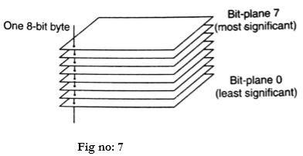

Bit plane slicing is a method of representing an image with one or more bits of the byte used for each pixel. One can use only MSB to represent the pixel, which reduces the original gray level to a binary image. The three main goals of bit plane slicing is:

* Converting a gray level image to a binary image.
* Representing an image with fewer bits and corresponding the image to a smaller size
* Enhancing the image by focussing.

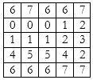

**Bit plane slicing:**

Since the given image has a maximum grey level of 7, it is a 3-bit image. We convert the image to binary and separate the bit planes.

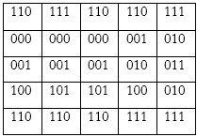

Separating the bit planes, we obtain

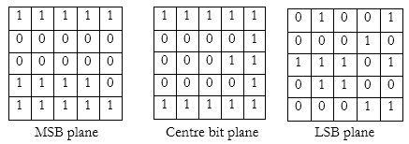

**Conclusion:** Thus, we have successfully learned and implemented about Contrast Stretching, Dynamic range compression & Bit plane Slicing.

**Code:**

img = cv2.imread('C:\\Users\\asus\\Desktop\\car.png')

original = img.copy()

xp = [0, 64, 128, 192, 255]

fp = [0, 16, 128, 240, 255]

x = np.arange(256)

table = np.interp(x, xp, fp).astype('uint8')

img = cv2.LUT(img, table)

cv2.imshow("original", original)

cv2.imshow("Output", img)

cv2.waitKey(0)

cv2.destroyAllWindows()

**Output:**

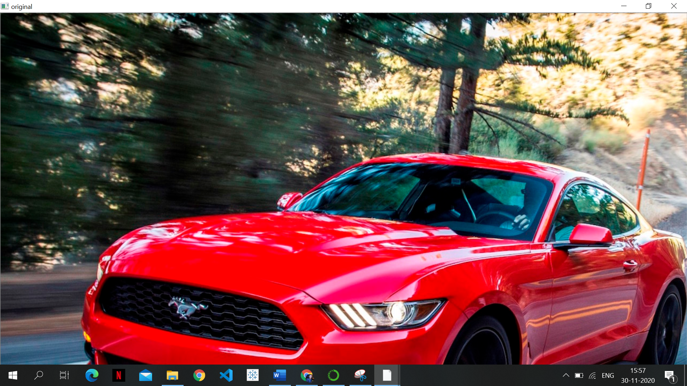

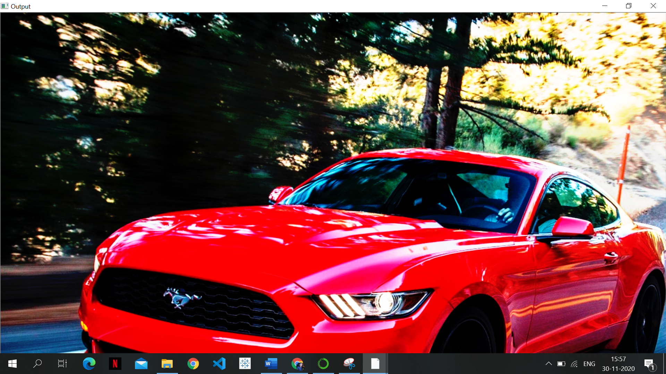

**Experiment 08**

# Aim: Implementation of Histogram Processing.

**Theory:**

**Histogram Processing:**

In digital image processing, the histogram is used for graphical representation of a digital image. A graph is a plot by the number of pixels for each tonal value. Nowadays, image histogram is present in digital cameras. Photographers use them to see the distribution of tones captured.

In a graph, the horizontal axis of the graph is used to represent tonal variations whereas the vertical axis is used to represent the number of pixels in that particular pixel. Black and dark areas are represented in the left side of the horizontal axis, medium grey color is represented in the middle, and the vertical axis represents the size of the area.

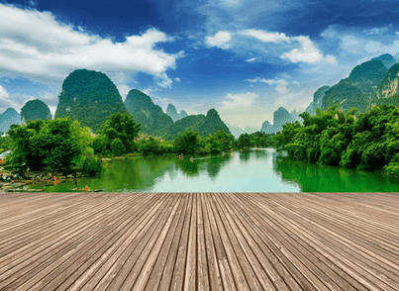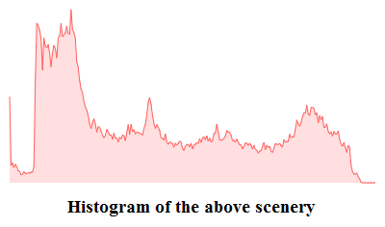

## Applications of Histograms

1. In digital image processing, histograms are used for simple calculations in software.
2. It is used to analyze an image. Properties of an image can be predicted by the detailed study of the histogram.
3. The brightness of the image can be adjusted by having the details of its histogram.
4. The contrast of the image can be adjusted according to the need by having details of the x-axis of a histogram.
5. It is used for image equalization. Gray level intensities are expanded along the x-axis to produce a high contrast image.
6. Histograms are used in thresholding as it improves the appearance of the image.
7. If we have input and output histogram of an image, we can determine which type of transformation is applied in the algorithm.

## Histogram Processing Techniques

### Histogram Sliding

In Histogram sliding, the complete histogram is shifted towards rightwards or leftwards. When a histogram is shifted towards the right or left, clear changes are seen in the brightness of the image. The brightness of the image is defined by the intensity of light which is emitted by a particular light source.

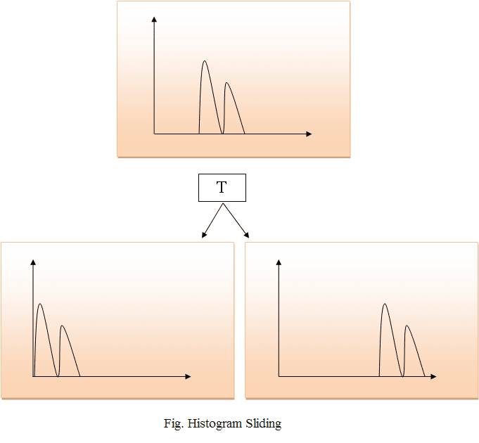

### Histogram Stretching

In histogram stretching, contrast of an image is increased. The contrast of an image is defined between the maximum and minimum value of pixel intensity.

If we want to increase the contrast of an image, histogram of that image will be fully stretched and covered the dynamic range of the histogram.

From histogram of an image, we can check that the image has low or high contrast.

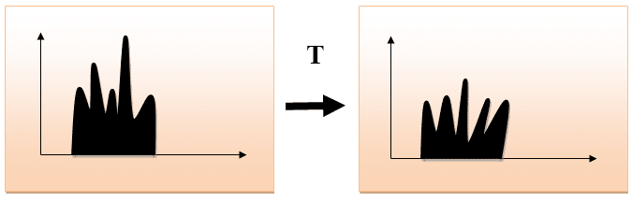

### Histogram Equalization

Histogram equalization is used for equalizing all the pixel values of an image. Transformation is done in such a way that uniform flattened histogram is produced.

Histogram equalization increases the dynamic range of pixel values and makes an equal count of pixels at each level which produces a flat histogram with high contrast image.

While stretching histogram, the shape of histogram remains the same whereas in Histogram equalization, the shape of histogram changes and it generates only one image.

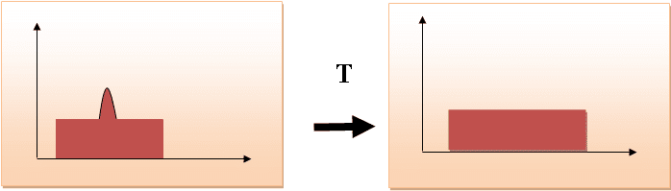

**Conclusion:** Thus, we have studied about histogram processing and implemented histogram equalization successfully.

**Code:**

image = cv2.imread("C:\\Users\\asus\\Desktop\\car.png")

# convert image from RGB to HSV

img_hsv = cv2.cvtColor(image, cv2.COLOR_RGB2HSV)

# Histogram equalisation on the V-channel

img_hsv[:, :, 2] = cv2.equalizeHist(img_hsv[:, :, 2])

# convert image back from HSV to RGB

image = cv2.cvtColor(img_hsv, cv2.COLOR_HSV2RGB)

cv2.imshow("equalizeHist", image)

cv2.waitKey(0)

**Output:**

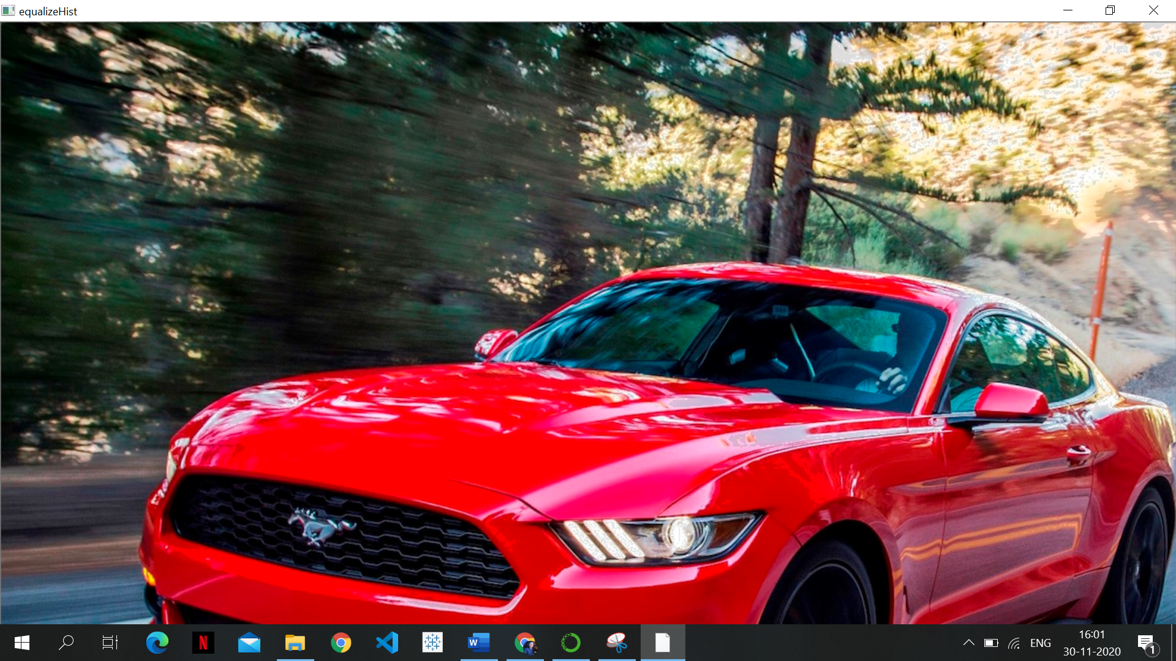

**Experiment 09**

**Aim:** Implementation of Image smoothing/ Image sharpening.

**Theory:**

**Image Smoothing:**

Image smoothing filters, which include the Gaussian, Maximum, Mean, Median, Minimum, Non-Local Means, Percentile, and Rank filters, can be applied to reduce the amount of noise in an image. You should note that although these filters can effectively reduce noise, they must be used with care so as to not alter important information contained in the image. You should also note that in many cases, edge detection or enhancement should not be applied before smoothing.

**Gaussian**

The effect of applying the Gaussian filter is to blur an image and remove detail and noise. In this sense it is similar to the Mean filter. However, it uses a kernel that represents the shape of a Gaussian or *bell-shaped* hump. In contrast to the Mean filter’s uniformly weighted average, the Gaussian filter outputs a weighted average of each pixel’s neighborhood, with the average weighted more towards the value of the central pixels. Because of this, the Gaussian filter provides gentler smoothing and preserves edges better than a similarly sized Mean filter.

One of the principle justifications for using the Gaussian filter for smoothing is due to its frequency response. Most convolution-based smoothing filters act as lowpass frequency filters. This means that their effect is to remove high spatial frequency components from an image. By choosing an appropriately sized Gaussian you can be fairly confident about what range of spatial frequencies will be present in the image after filtering, which is not the case with the Mean filter. The Gaussian filter is also attracting attention from computational biologists because it has been attributed with some amount of biological plausibility. For example, some cells in the visual pathways of the brain often have an approximately Gaussian response.

You should note that Gaussian smoothing is commonly used prior to edge detection since many edge-detection filters are sensitive to noise.

**Mean**

Mean filtering is a simple method of smoothing and diminishing noise in images by eliminating pixel values that are unrepresentative of their surroundings. The idea of mean filtering is to replace each pixel value in an image with the mean or average value of its neighbors, including itself.

Like other convolution filters, the Mean filter is based around a kernel, which represents the shape and size of the neighborhood to be sampled when calculating the mean. Often a 3x3 square kernel is used, although larger kernels can be used for more severe smoothing. Note that a small kernel can be applied more than once in order to produce a similar, but not identical effect, as a single pass with a large kernel.

You may notice that although noise is less apparent after mean filtering, the image has been softened or blurred and has lost high frequency detail. This usually occurs due to the following limitations of the filter:

* A single pixel with a very unrepresentative value can significantly affect the mean value of all the pixels in its neighborhood.
* When the filter neighborhood straddles an edge, the filter will interpolate new values for pixels on the edge. This may be problematic if sharp edges are required in the output.

Both of these problems can be tackled by the Median filter, which is used more often for reducing noise than the Mean filter. Other convolution filters that do not calculate the mean of a neighborhood are also often used for smoothing. One of the most common of these is the Gaussian filter.

**Median**

The Median filter is normally used to reduce noise in an image, and can often do a better job of preserving detail and edges in an image than the Mean filter. Like the Mean filter, this filter considers each pixel in the image in turn and looks at its nearby neighbors to decide whether or not it is representative of its surroundings. However, instead of simply replacing the pixel value with the mean of neighboring pixel values, it replaces it with the median of those values. Median filters are particularly useful for removing random intensity spikes that often occur in images captured in microscopes.

The following illustration shows how this filter works. The median is calculated by first sorting all the pixel values from the surrounding neighborhood, in this case a 3x3 square, into numerical order and then replacing the pixel being considered with the middle pixel value.

Median filter

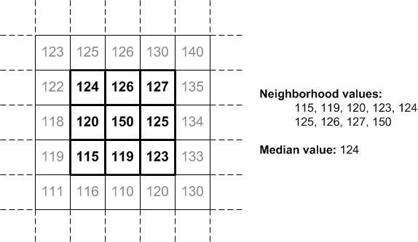

As shown in the illustration, the central pixel value of 150 is not representative of the surrounding pixels and is replaced with the median value of 124. You should note that using larger neighborhoods will produce more severe smoothing.

By calculating the median value of a neighborhood rather than the mean, the Median filter has two main advantages over the Mean filter:

* The median is more robust than the mean and so a single very unrepresentative pixel in a neighborhood will not affect the median value significantly. For example, in datasets that have been corrupted with *salt-and-pepper noise* (scatter dots).
* Since the median value must actually be the value of one of the pixels in the neighborhood, the Median filter does not create unrealistic pixel values when the filter straddles an edge. For this reason it is much better at preserving sharp edges than the Mean filter.

However, the Median filter is sometimes not as subjectively good at dealing with large amounts of Gaussian noise as the Mean filter. It is also relatively complex to compute.

**Non-Local Means**

Unlike the Mean filter, which takes the mean value of a group of pixels surrounding a target pixel to smooth an image, the Non-Local Means filter takes the mean of all pixels in the image, weighted by how similar they are to the target pixel. Applying this filter can result in greater post-filtering clarity with minimal loss of detail when compared with mean filtering. In many cases, the Non-Local Means or Bilateral filter should be your first choice for smoothing noisy images.

You should note that non-local means filtering works most effectively if the noise present in the data is white noise, in which case most features present in the image will be preserved, even small and thin ones.

**Image Sharpening**

What is Sharpening?

Sharpening then, is a technique for increasing the *apparent*sharpness of an image. Once an image is captured, Photoshop can’t magically any more details: the actual resolution remains fixed. Yes, you can increase the file’s size but the algorithms any image editor uses to do so will decrease the sharpness of the details.

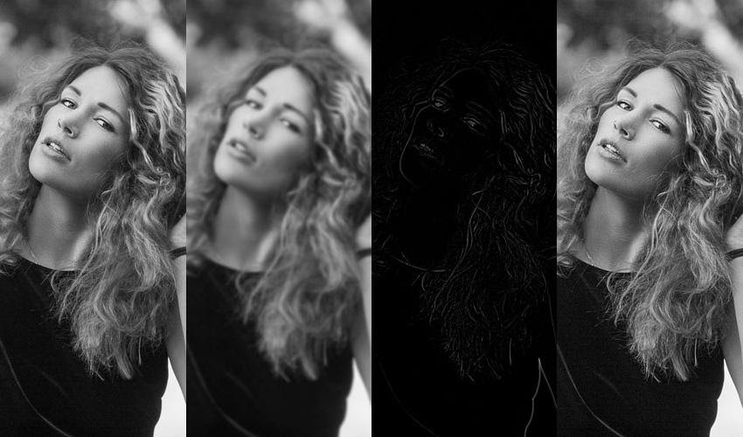

In other words, the only way to increase apparent sharpness is by increasing acutance. If you want your image to look sharper, you need to add edge contrast.

Here I've mimicked the **Unsharp Mask** effect in Photoshop. The first image is the original file, the second is a blurred copy, the third is the one subtracted from the other so as to detect the edges, and the fourth is the original image sharpened using the edge layer. Unsharp masking is the oldest sharpening technique. It subtracts a blurred (unsharp) copy from the original image to detect any edges. A mask is made with this edge detail. Contrast is then increased at the edges and the effect is applied to the original image. While unsharp masking was originally a film technique, it’s now the basis of digital sharpening.

**Why Sharpen Images?**

There are three main reasons to sharpen your image: to overcome blurring introduced by camera equipment, to draw attention to certain areas and to increase legibility.

RAW files from any modern camera are always slightly unsharp. Every step of the image capturing process introduces blur. As the light passes through the lens elements—no matter how well made—some definition is lost. When the sensor processes the photons falling on it, the sharpest transitions are averaged out and slightly blurred. When the three different colour channels are interpolated to create the final image, again, a small amount of blur is introduced.

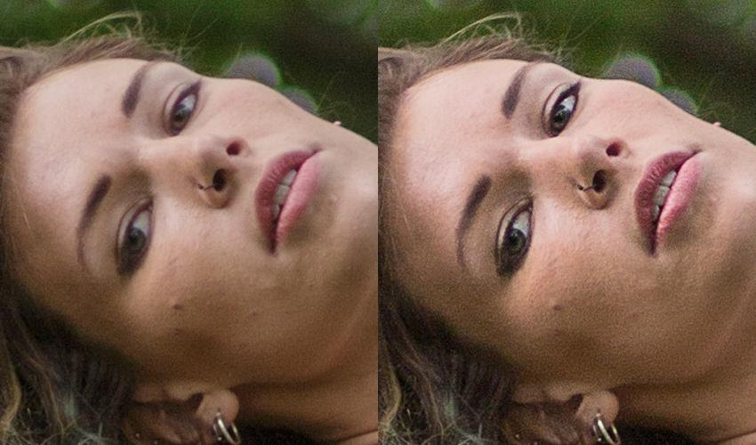

A straight out of camera file versus a sharpened one. I've removed all colour toning and retouching for the best comparison.

Second, human eyes are attracted to contrast. When we look at a photo, we are drawn to the sharpest details. If you’re trying to direct a viewer, selective sharpening is one of the best ways to do it.

Finally, sharpening an image makes it easier to see important details. Text becomes easier to read, individual leaves stand out and faces in a crowd become more distinct.

**Conclusion:** Image smoothing/ Image sharpening is successfully studied in detail.

**Code:**

**Image Smoothing**

# importing libraries

import cv2

import numpy as np

image = cv2.imread('C:\\Users\\asus\\Desktop\\car.png')

cv2.imshow('Original Image', image)

cv2.waitKey(0)

# Gaussian Blur

Gaussian = cv2.GaussianBlur(image, (7, 7), 0)

cv2.imshow('Gaussian Blurring', Gaussian)

cv2.waitKey(0)

# Median Blur

median = cv2.medianBlur(image, 5)

cv2.imshow('Median Blurring', median)

cv2.waitKey(0)

# Bilateral Blur

bilateral = cv2.bilateralFilter(image, 9, 75, 75)

cv2.imshow('Bilateral Blurring', bilateral)

cv2.waitKey(0)

cv2.destroyAllWindows()

**Output:**

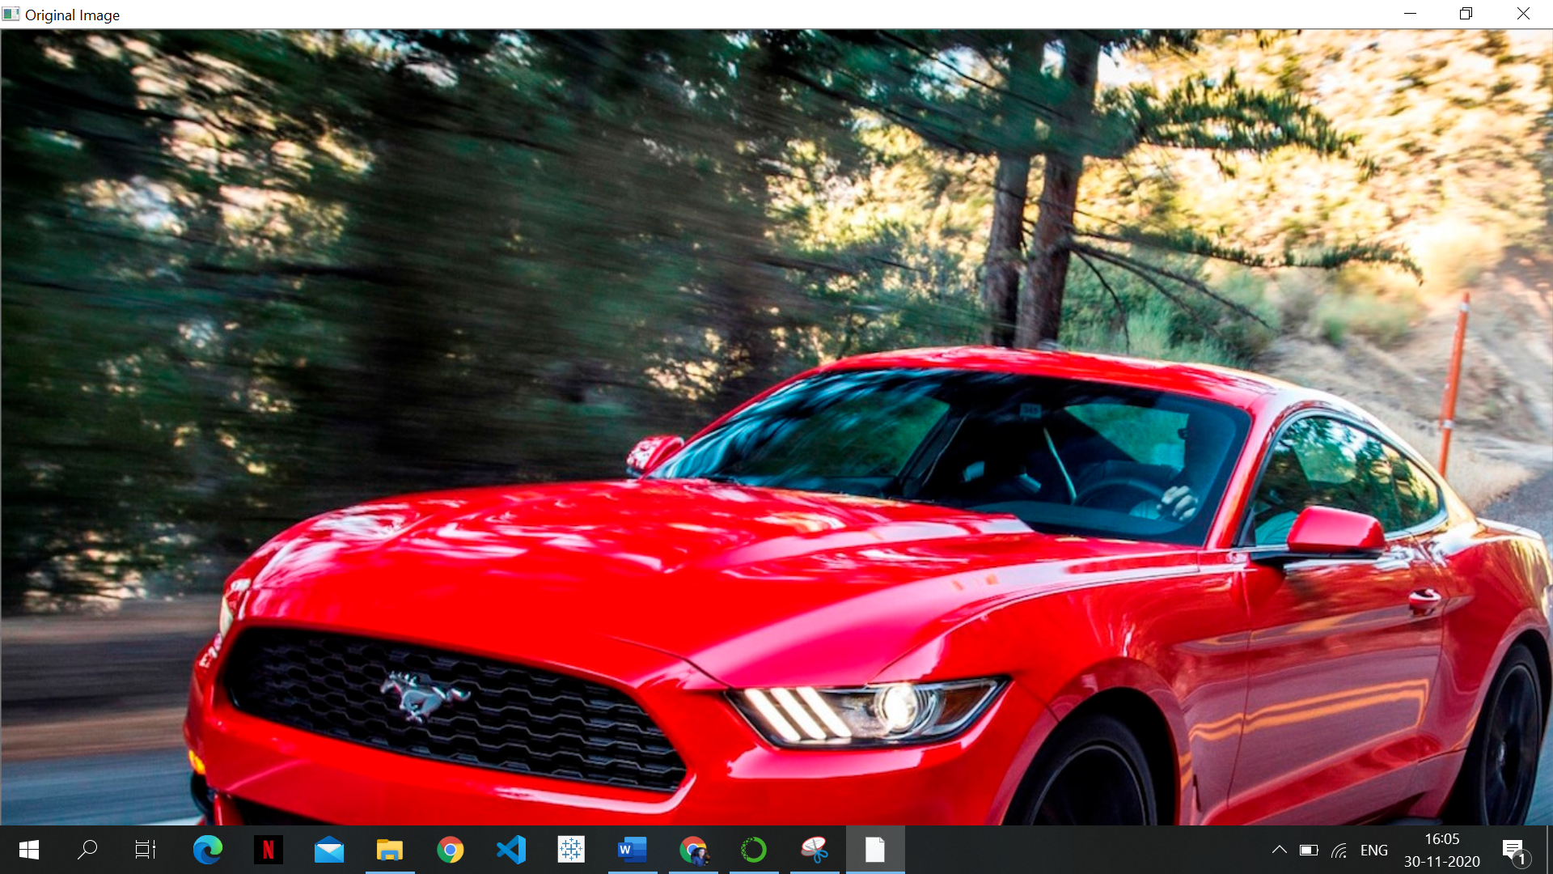







**Image Sharpening:**

from PIL import Image

from PIL import ImageFilter

# Open an already existing image

imageObject = Image.open("C:\\Users\\asus\\Desktop\\car.png");

imageObject.show();

# Apply sharp filter

sharpened1 = imageObject.filter(ImageFilter.SHARPEN);

sharpened2 = sharpened1.filter(ImageFilter.SHARPEN);

# Show the sharpened images

sharpened1.show("image1_sharp");

sharpened2.show("image2_sharp");

**Output:**

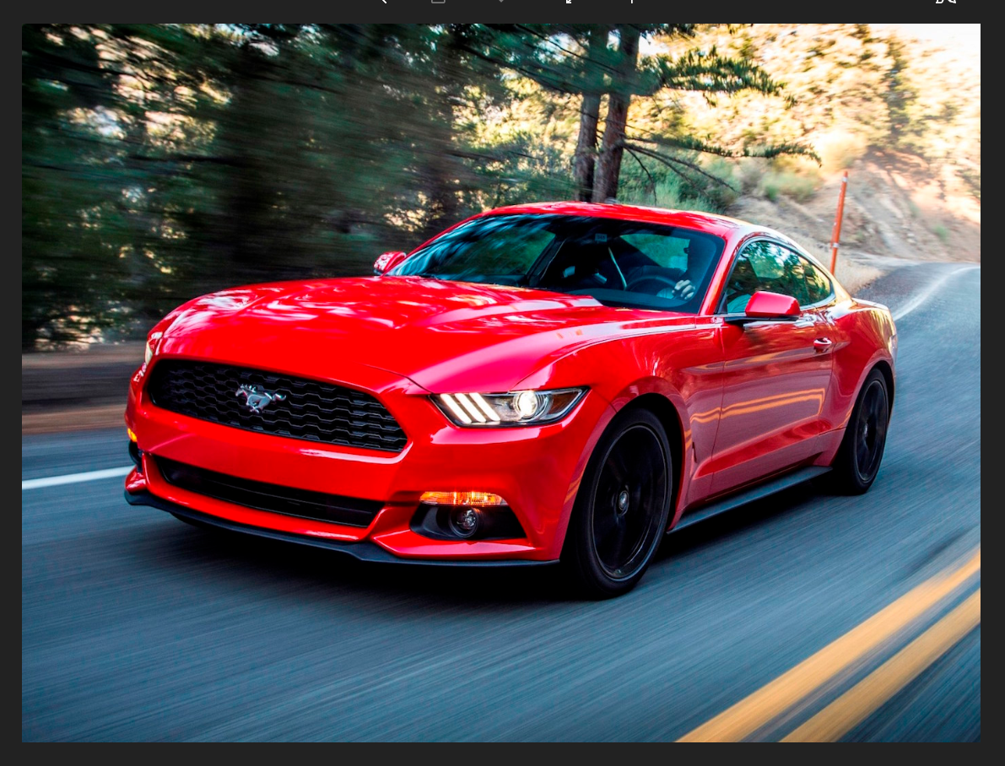

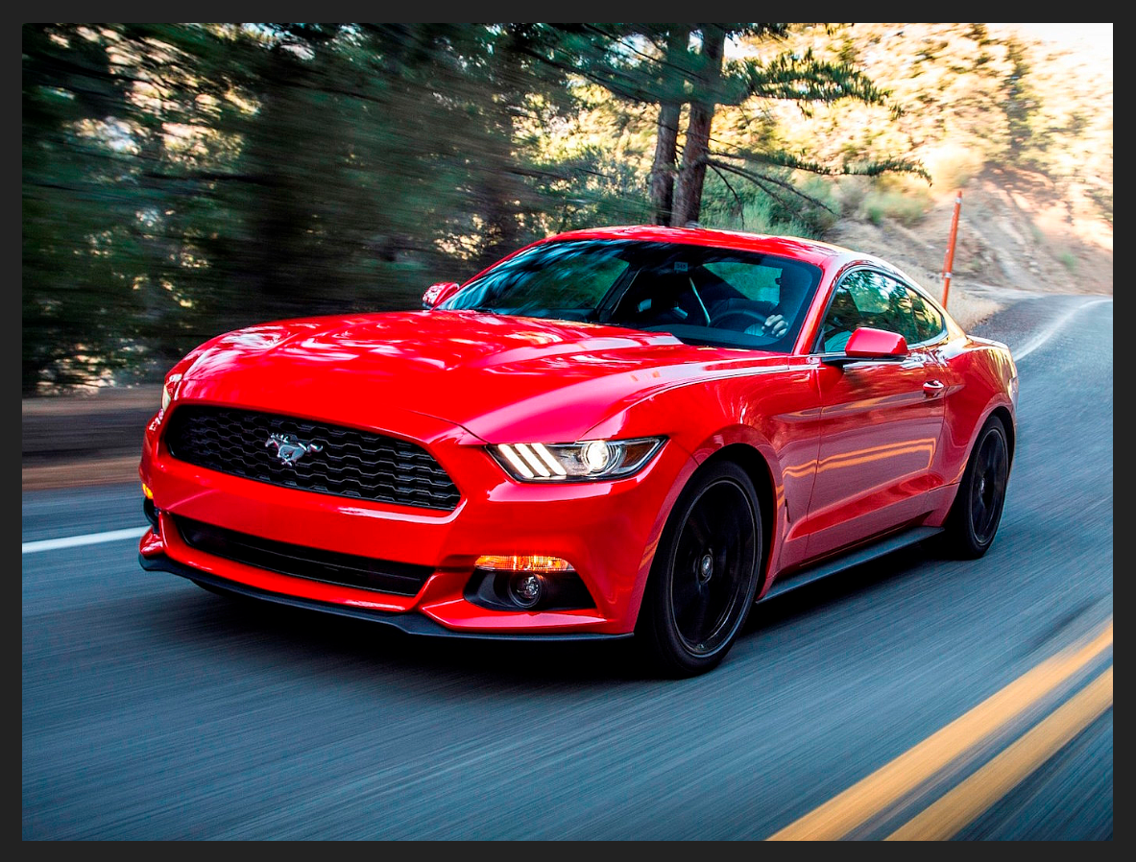

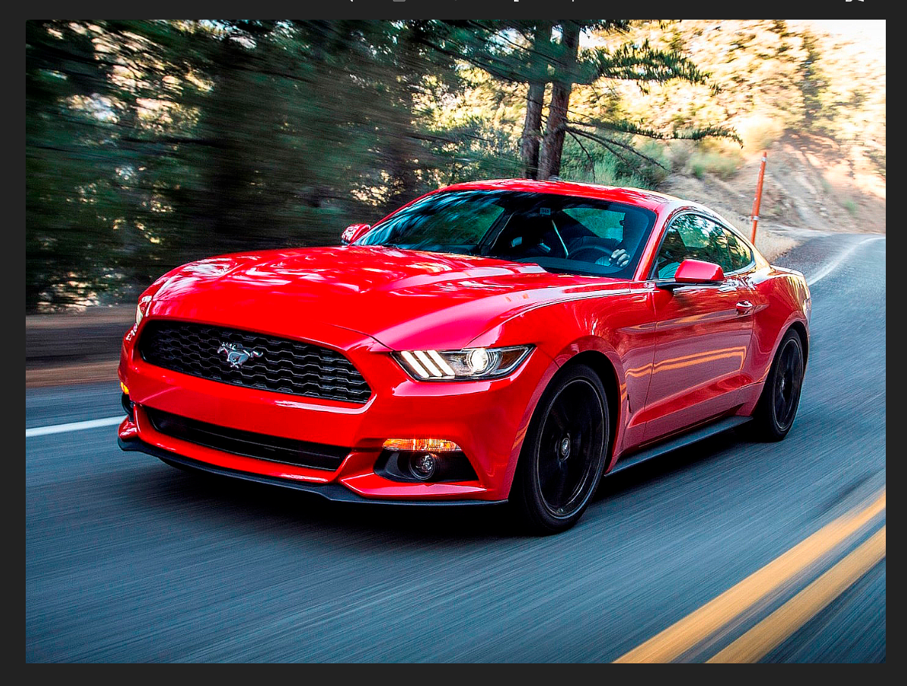

**Experiment 10**

**Aim:** Implementation of Edge detection using Sobel and Previtt masks.

**Theory:**

**Edges** are significant local changes of intensity in a digital image. An edge can be defined as a set of connected pixels that forms a boundary between two disjoint regions. There are three types of edges:

* Horizontal edges
* Vertical edges
* Diagonal edges

**Edge Detection** is a method of segmenting an image into regions of discontinuity. It is a widely used technique in digital image processing like 

* pattern recognition
* image morphology
* feature extraction

Edge detection allows users to observe the features of an image for a significant change in the gray level. This texture indicating the end of one region in the image and the beginning of another. It reduces the amount of data in an image and preserves the structural properties of an image.

**Edge Detection Operators** are of two types:

* **Gradient –** based operator which computes first-order derivations in a digital image like, Sobel operator, Prewitt operator, Robert operator
* **Gaussian –** based operator which computes second-order derivations in a digital image like, Canny edge detector, Laplacian of Gaussian

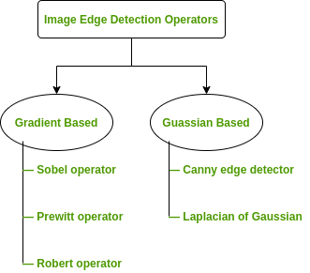

**Sobel Operator:** It is a discrete differentiation operator. It computes the gradient approximation of image intensity function for image edge detection. At the pixels of an image, the Sobel operator produces either the normal to a vector or the corresponding gradient vector. It uses two 3 x 3 kernels or masks which are convolved with the input image to calculate the vertical and horizontal derivative approximation respectively.

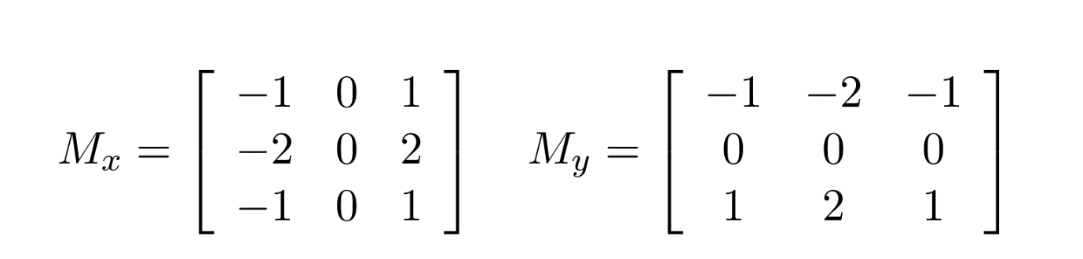

***Advantages:*** 

1. Simple and time efficient computation
2. Very easy at searching for smooth edges

***Limitations:*** 

1. Diagonal direction points are not preserved always
2. Highly sensitive to noise
3. Not very accurate in edge detection
4. Detect with thick and rough edges does not give appropriate results.

**Prewitt Operator:** This operator is almost similar to the sobel operator. It also detects vertical and horizontal edges of an image. It is one of the best ways to detect the orientation and magnitude of an image. It uses the kernels or masks.

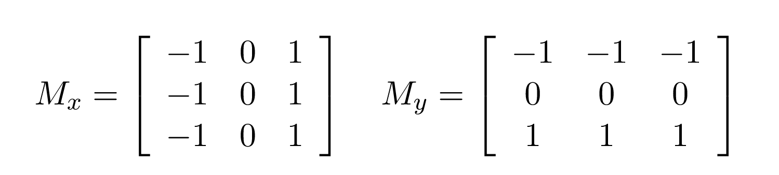  
 ***Advantages:*** 

1. Good performance on detecting vertical and horizontal edges
2. Best operator to detect the orientation of an image

***Limitations:***

1. The magnitude of coefficient is fixed and cannot be changed
2. Diagonal direction points are not preserved always

**Robert Operator:** This gradient-based operator computes the sum of squares of the differences between diagonally adjacent pixels in an image through discrete differentiation. Then the gradient approximation is made. It uses the following 2 x 2 kernels or masks.

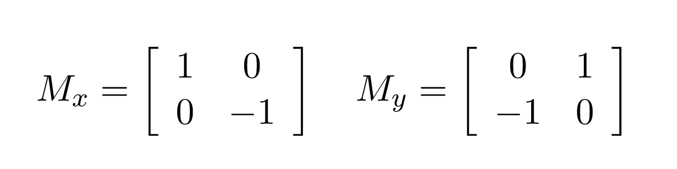  
 ***Advantages:*** 

1. Detection of edges and orientation are very easy
2. Diagonal direction points are preserved

***Limitations:*** 

1. Very sensitive to noise
2. Not very accurate in edge detection

**Marr-Hildreth Operator or Laplacian of Gaussian (LoG):** It is a gaussian-based operator which uses the Laplacian to take the second derivative of an image. This really works well when the transition of the grey level seems to be abrupt. It works on the zero-crossing method i.e when the second-order derivative crosses zero, then that particular location corresponds to a maximum level. It is called an edge location. Here the Gaussian operator reduces the noise and the Laplacian operator detects the sharp edges.   
The Gaussian function is defined by the formula:



***Advantages:*** 

1. Easy to detect edges and their various orientations
2. There is fixed characteristics in all directions

***Limitations:*** 

1. Very sensitive to noise
2. The localization error may be severe at curved edges
3. It generates noisy responses that do not correspond to edges, so-called “false edges”

**Canny Operator:** It is a gaussian-based operator in detecting edges. This operator is not susceptible to noise. It extracts image features without affecting or altering the feature. Canny edge detector have advanced algorithm derived from the previous work of Laplacian of Gaussian operator. It is widely used an optimal edge detection technique. It detects edges based on three criteria:

1. Low error rate
2. Edge points must be accurately localized
3. There should be just one single edge response

***Advantages:*** 

1. It has good localization
2. It extract image features without altering the features
3. Less Sensitive to noise

***Limitations:*** 

1. There is false zero crossing
2. Complex computation and time consuming

**Some Real-world Applications of Image Edge Detection:** 

* medical imaging, study of anatomical structure
* locate an object in satellite images
* automatic traffic controlling systems
* face recognition, and fingerprint recognition

**Conclusion:** Thus, we have successfully implemented and learned various edge detection techniques.

**Code:**

**Canny Edge Detection**

import cv2

import numpy as np

img = cv2.imread('C:\\Users\\asus\\Desktop\\car.png',0)

edges = cv2.Canny(img,100,100)

cv2.imshow("edge",edges)

cv2.waitKey(0)

cv2.destroyAllWindows()

**Output:**

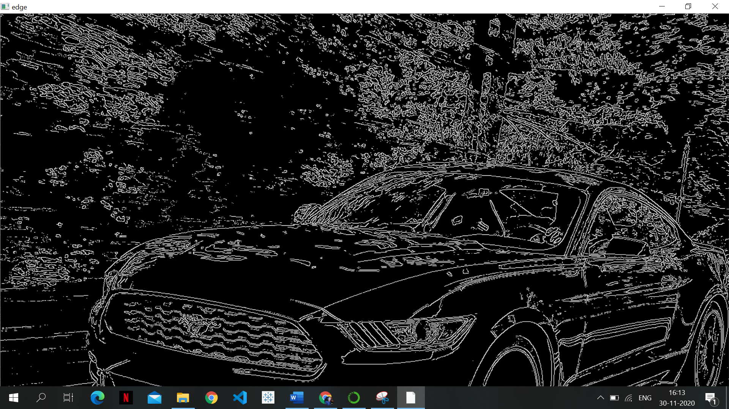

**Sobel and Laplacian Edge detection**

import cv2

import numpy as np

from matplotlib import pyplot as plt

# loading image

#img0 = cv2.imread('SanFrancisco.jpg',)

img0 = cv2.imread(“C:\\Users\\asus\\Desktop\\car.png”,)

# converting to gray scale

gray = cv2.cvtColor(img0, cv2.COLOR_BGR2GRAY)

# remove noise

img = cv2.GaussianBlur(gray,(3,3),0)

# convolute with proper kernels

laplacian = cv2.Laplacian(img,cv2.CV_64F)

sobelx = cv2.Sobel(img,cv2.CV_64F,1,0,ksize=5)  # x

sobely = cv2.Sobel(img,cv2.CV_64F,0,1,ksize=5)  # y

cv2.imshow("laplace",laplacian)

plt.subplot(2,2,1),plt.imshow(img,cmap = 'gray')

plt.title('Original'), plt.xticks([]), plt.yticks([])

plt.subplot(2,2,2),plt.imshow(laplacian,cmap = 'gray')

plt.title('Laplacian'), plt.xticks([]), plt.yticks([])

plt.subplot(2,2,3),plt.imshow(sobelx,cmap = 'gray')

plt.title('Sobel X'), plt.xticks([]), plt.yticks([])

plt.subplot(2,2,4),plt.imshow(sobely,cmap = 'gray')

plt.title('Sobel Y'), plt.xticks([]), plt.yticks([])

plt.show()

**Output:**

